EduGenie – Google Gemini Powered Learning Assistant
Project Design Phase-II
Technology Stack (Architecture & Stack)
Date | 28/09/2026
Team ID | SWTID-2026-EG01
Project Name | EduGenie
Submitted by: Rahul R | Mentor: Sasi B
Technical Architecture:
EduGenie follows a lightweight layered architecture where the browser-based HTML/CSS frontend communicates with a FastAPI backend. Reasoning-heavy tasks (Q&A, quiz generation, summarization, learning paths) are delegated to the cloud-based Gemini 1.5 Pro API, while concept explanation is handled locally through the instruction-tuned LaMini-Flan-T5-783M model for speed and CPU efficiency.
The deliverable includes the architectural diagram below along with the component and characteristic tables.
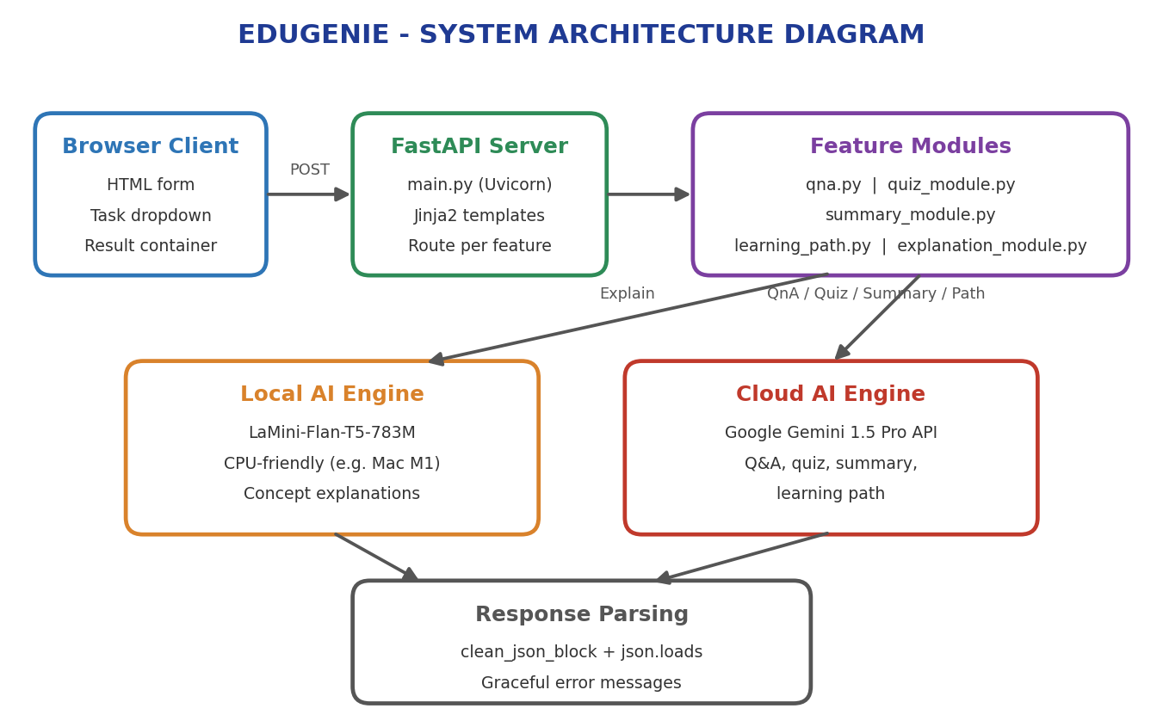
Table-1: Components & Technologies
S.No | Component | Description | Technology
1 | Frontend | HTML form with task dropdown, text area, and result container | HTML, CSS, Jinja2 templates
2 | Backend Server | Routes requests to the correct module and returns rendered results | FastAPI, Uvicorn (ASGI server)
3 | Explanation Engine | Generates simplified, concise concept explanations locally | LaMini-Flan-T5-783M
4 | Cloud AI Engine | Handles Q&A, quiz generation, summarization, and learning-path generation | Google Gemini 1.5 Pro API
5 | Response Parsing | Cleans Markdown-wrapped JSON from the AI and parses it safely | Python (clean_json_block), json

Table-2: Application Characteristics
S.No | Characteristics | Description | Technology
1 | Lightweight Frameworks | Minimal backend and templating footprint | FastAPI, Jinja2
2 | Hybrid AI Architecture | Combines a local CPU-friendly model with a cloud reasoning model | LaMini-Flan-T5 + Gemini 1.5 Pro
3 | Modularity | Each learning feature lives in its own module file | explanation_module.py, qna.py, quiz_module.py, summary_module.py, learning_path.py
4 | Structured AI Output | Quiz responses are returned as clean, parseable JSON | Gemini structured prompting, JSON cleaning
5 | Device Efficiency | Runs well on lightweight hardware, including Mac M1 | CPU-compatible local model inference

